## Instruction of the Metro System Testing Application

1.Purpose: The aim of this application is to figure out, in a fixed grid area, whether or not a certain designed metro system is able to satisfy the travel demand and able to earn money for the metro company. The application is based on a certain defined case. The input is 1) the location of metro stations, 2) the lines that connect stations, 3) the frequency of vehicles, and 4) capacity of vehicles. The output is 1) a trip end O-D matrix, 2) a comparison of traffic volume and transport capacity, and 3) financial cost, revenue and income.

2.Methodology: The theory underneath the application is the Four-Step Travel Demand Model. It contains trip generation, trip distribution, mode choice and traffic assignment. Except for mode choice, all the other three steps are applied in this application.

3.Assumption: 1) The grid network is always a squre. 2) Metro and walking is the only two ways of travel. When considering which way to travel, travelers always take metro prior to walking. This means travelers want to walk as less distance as possible. 3) Travelers always choose the metro station that is closest to their origin. If more than one stations are equally closest to a traveler, the shortest path algorithm will help traveler decide which station to get on. Same principle goes for choosing which station to get off to reach travelers’ destinations. 4) There are two situations that a traveler totally chooses walking, instead of taking metro. The first situation is when the origin zone of a trip is same as the destination zone of a trip. The second situation is when the distance between two zones is so small that the shortest path by metro only passes one metro station. In these two cases, there is no need to take metro, so the number of trips will be 0.

4.Case data: The application is based on a certain defined case. In this case, an area is divided into a 5 rows*5 columns grid network. Each grid cell is a zone. The total number of zones is 25. It can be seen in the picture below.

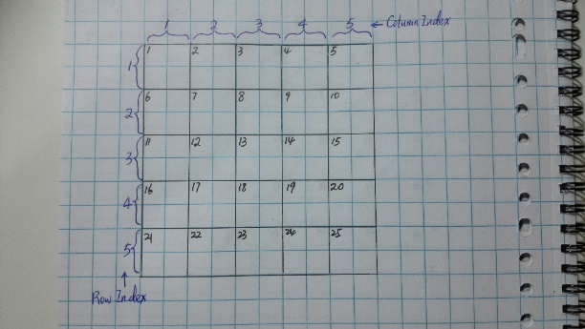

Besides the grid cells, the data of the case contain four parts. They are all saved in the folder of “CaseData”. All the units can be seen in the excel file “unit of all variables”.

1. Social Economic Factors: These data are used for calculating trip generation. It contains number of inhabitants in a zone, number of jobs in a zone, average income of the inhabitants in a zone, average car ownership of inhabitants in a zone, average household structure of in habitants in a zone, average family size of in habitants in a zone

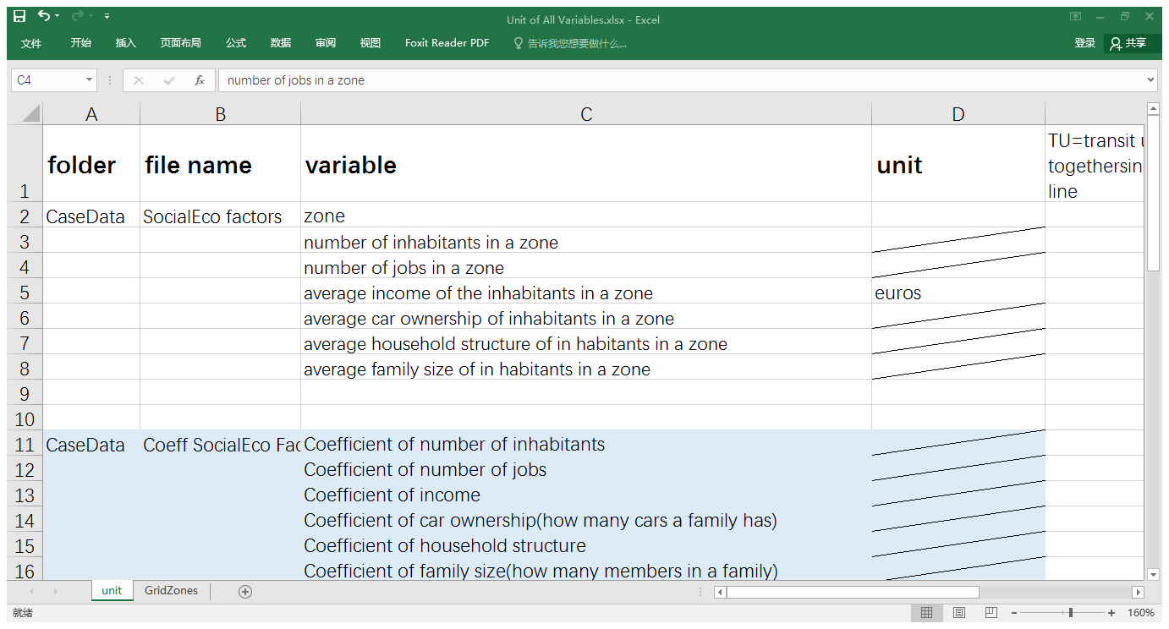

1. Coefficients of Social Economic Factors: These data are used for calculating trip generation.
2. Impedance Calculation Factors: There data are used for calculating impedance from a zone to another zone.

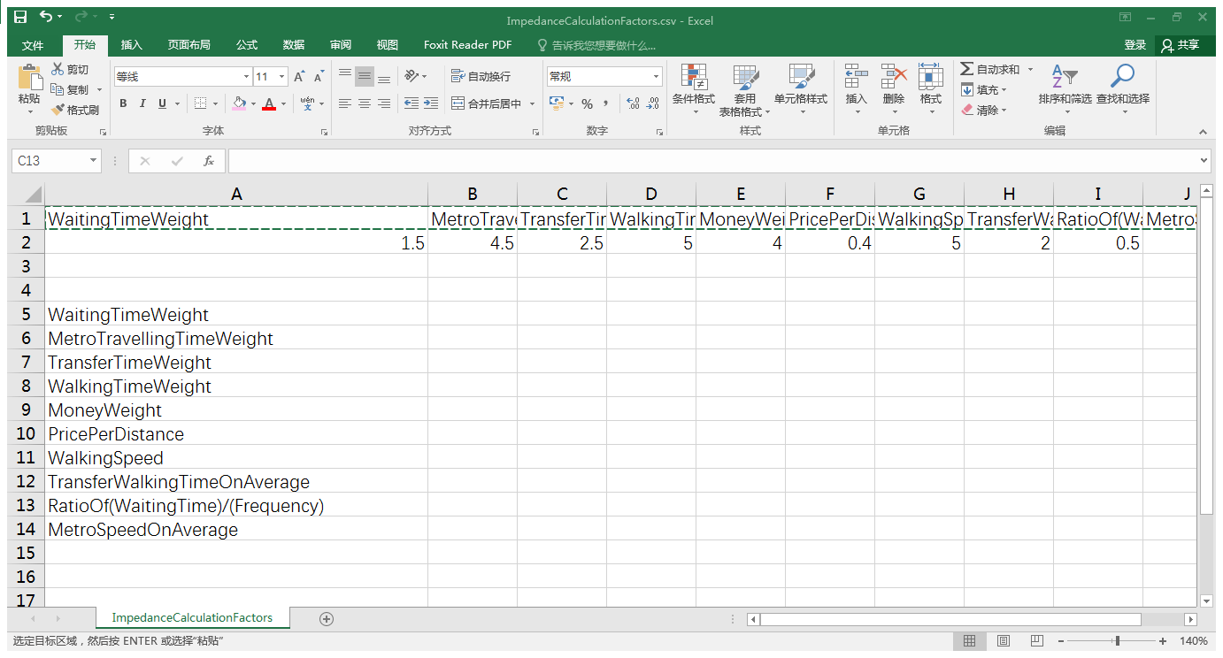

1. Budget Data: These data are used for calculating financial cost, revenue and income.

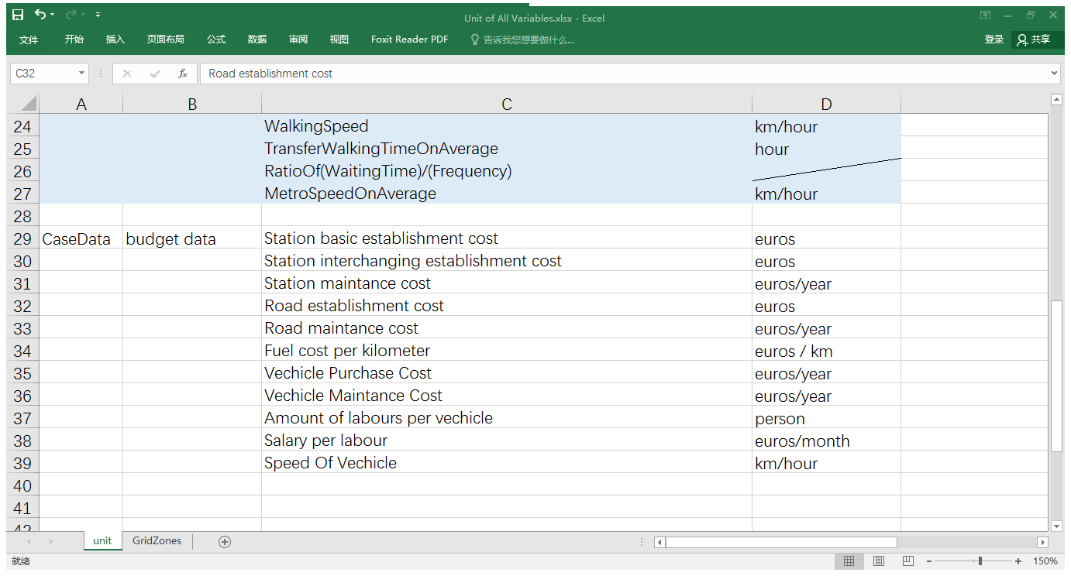

Change case: It is possible to change the case data. The user can change “GridSize”in the code of this application. After that, the zone code and relevant data in the case data files should also be changes.

5. Input:

The user is able to input the data of their designed metro system. Each metro system is called “a scenario”. Each scenario has a code, which is in %02d integer. In the folder "Scenario##", there are three files. The user needs to input the required data to these three files:

1. File “MetroStation##”: Input data on which station is located in which zone. Each zone should only contain no more than one metro station. The default location of a station in a zone is in the center of the zone. The codes of stations should be continuous integer. The data type of station code is integer.

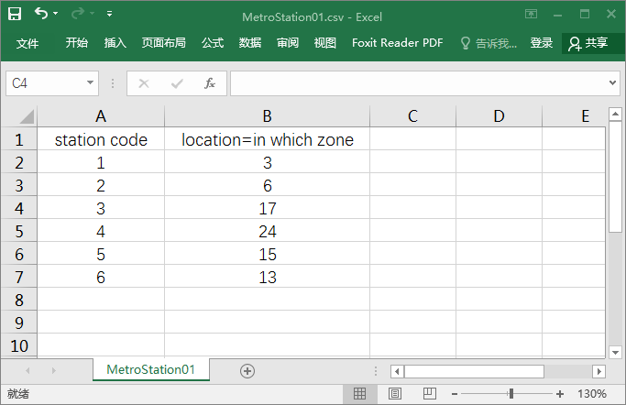

1. File “MetroLine##”: Input data on how stations are connected to each other. This means that, for each metro line, which stations it passes through. The codes of lines should be continuous integer. The last word “Station” should exactly on the column of the rightest station code. The left picture below shows the metro line data of a designed metro system on the right picture.

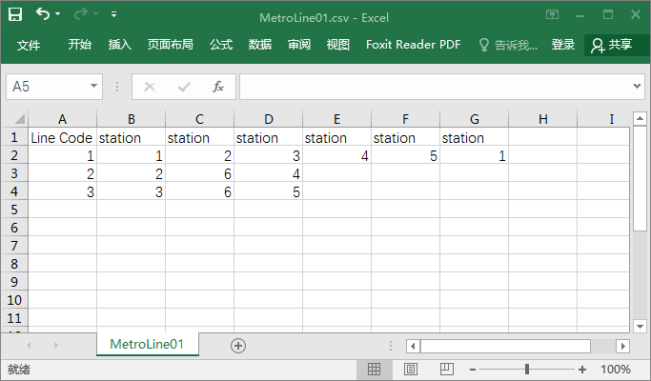 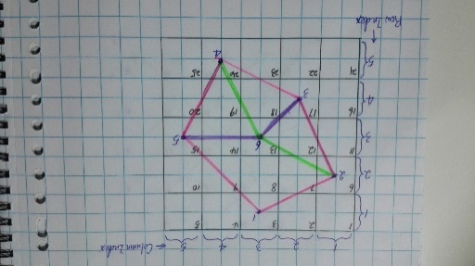

1. File “MetroProperty##”: Input data on frequency and capacity. Frequency means how often the schedule of the vehicles on a certain line is. The unit of frequency is transit unit/hour. Capacity means how many people a vehicle is able to carry. The unit of capacity is persons/vehicle. The type of data in frequency and capacity is float.

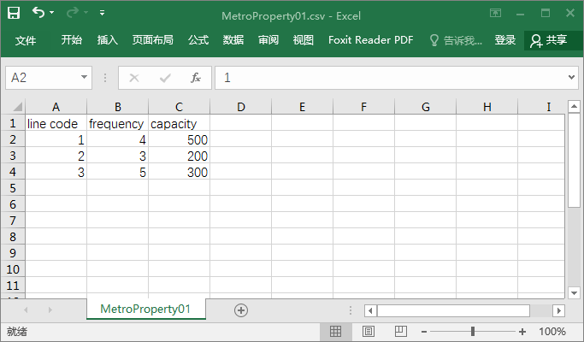

6. Output:

After input the scenario code into the main function “RunScenario(ScenarioCode)”, the output will be presented. The output of a scenario is in: “Output##”folder /“output##”file. The output of a scenario contains three parts:

1)A Trip End Origin-Destination Matrix: This is a result of trip generation and trip distribution. The format is show in the picture bellow. In the trip end matrix, “0” means there is no trip taking metro goes from an origin zone to a destination zone.

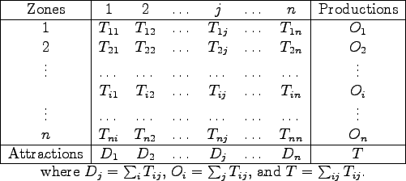

2)A Comparison among Traffic Capacity and Traffic Volume: This is a result of traffic assignment. It has two purposes. The first purpose is to show that how many trips go from each metro station to another metro station. This is called traffic volume. It can be seen in the pink part of the table below. It clearly presents which edges of which line has more than traffic volume than the other edges. So the user can make some improvement if needed. The second purpose is to show whether or not the transport capacity is able to bear the traffic volume. If the calculation result is a positive number which means the transport capacity is large enough, then the result shows “Succeed”. Otherwise, the result shows “Fail”. The calculation and result can be seen in the blue part of the table below.

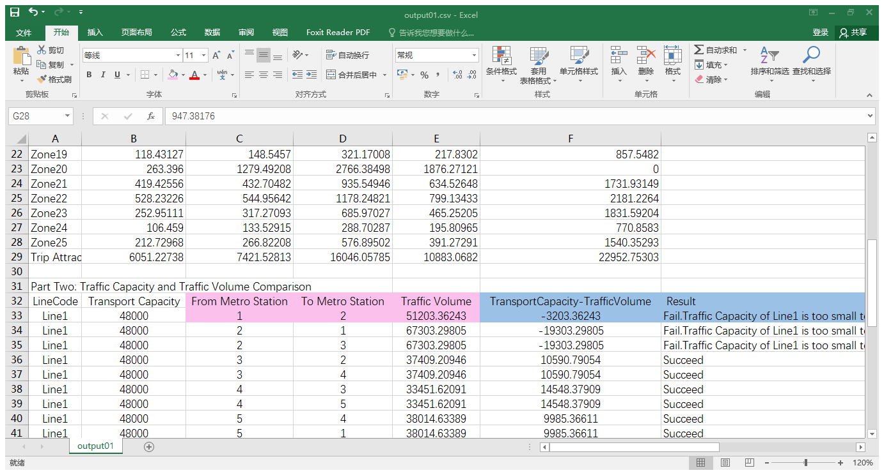

3)Financial Cost, Revenue and Income:

Financial cost contains two parts: establishment cost and operation cost

Establishment cost of the whole metro system (euros) = Station build-up cost + Road build-up cost + Vehicle purchasing cost

Operation cost of a line (euros/day) = Station maintenance cost + Road maintenance cost + Vehicle maintenance Cost + Labor cost

Revenue of a line (euros/day) = sum of (price per unit of distance * distance of an edge * traffic volume of an edge)

Income of a line (euros/day) = Revenue- Operation cost. The establishment cost is not taken into account when calculating income because establishment cost is not related to time.

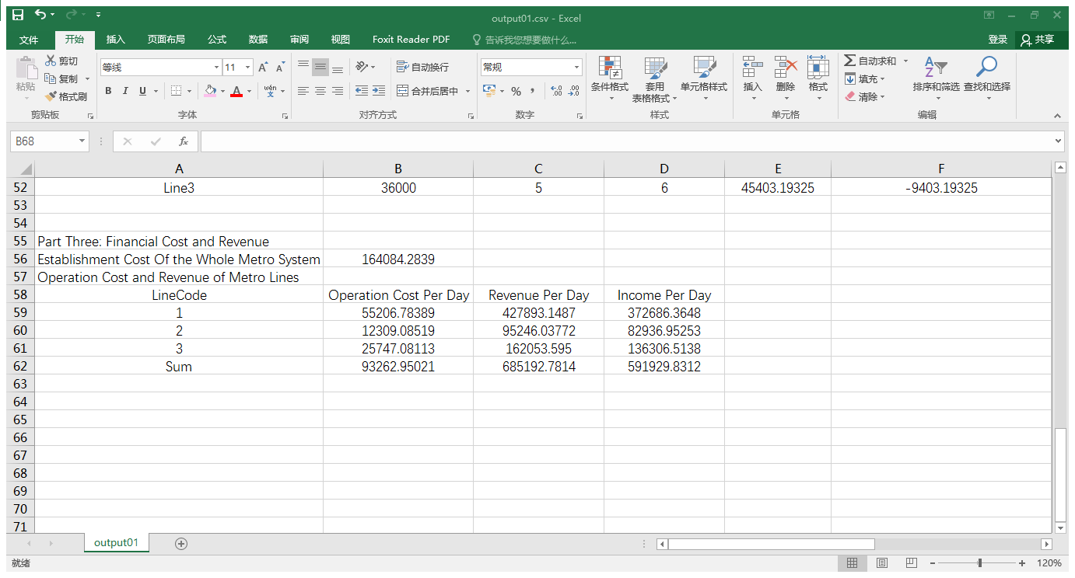

7. What user can do with the output

If the transport capacity does not satisfy the travel demand or the income does not satisfy user’s demand, improvements can be made. User is able to change the location of metro stations, the lines that connect stations, the frequency of vehicles, and capacity of vehicles. Not all of these four factors need to be changed at the same time. By analyzing the output, the user is expected to realize that, from which zone to which zone, the travel demand is larger than the others. So the user can make improvement according to this.